

**Espire Infolabs Private Limited**

Software Division

Integrated Quality Management System

**Performance Testing Report**

Project Name : Tate – Performance Testing

Client Name: Tate

**Version**: 1.0

**Document Reference No:** Espire-Tate Performance Testing Report

**Security Classification:** Restricted

**Issue Date:** July 26, 2017

|  |  |  |  |
| --- | --- | --- | --- |
| **Document Control** | | | |
| **Reference No.** | Espire-Tate Performance Testing Report | | |
| **Document Name** | **Performance Testing Report** | | |
| **Version No.** | 1.0 | | |
| **Document Status** | Definitive | | |
| **Issue Date** | July 26, 2017 | | |
| **Compliance Status** | Mandatory | | |
| **Review Period** | One year from the date of release or earlier if required on need basis | | |
| **Security Classification** | Restricted | | |
| **Distribution** | All Tate Performance Testing Project Team members through Project workspace on Corporate Intranet and Client representatives | | |
|  | **Name** | **Role** | **Signature** |
| **Authored by** | Ravinder Yadav | Test Analyst |  |
| **Reviewed by** | Yatender Sharma | Practice Lead - Testing |  |
| **Approved by** | ? | Project Manager |  |
| **Released by** | Abhinav Goyal | Project Manager |  |

|  |  |  |
| --- | --- | --- |
| Document Revision History | | |
| **Version** | **Release Date** | **Change Description** |
| 1.0 | July 26, 2017 | Initial Version , First Release |

Contents

1. Introduction 4

1.1 Overview 4

1.2 Purpose of Document 4

1.3 References 4

1.4 Definitions & Abbreviations 4

2. Scope 4

2.1 Scope 4

2.2 Out of Scope 5

2.3 Test Cases to be executed for performance testing of Tate application 5

3. Assumptions 5

4. Constraints 5

5. Testing Resource Management 6

5.1 Testing Resources Required 6

5.2 Roles and Responsibilities 6

6. Test Cases Preparation and Execution 6

6.1 Test Case Execution Details 6

7. Test Execution 7

8. Final recommendation from Perfomance Testing Team 14

# Introduction

## Overview

This document is to provide performance testing report of Tate project for Impellam Client. Tate is web based application which provide an interface for end users to carry out job search & job apply activities.

Tate systems are to be used by 40 users, so we need to do performance testing of system for 40 users.

## Purpose of Document

The purpose of this document is to share Test Cases executed during Performance Testing of POS application and findings of various sceanrios to BCH. This testing was conducted in IT Lab within Espire.

## References

|  |  |  |
| --- | --- | --- |
| **S.No.** | **Document** | **Description** |
| 1 | ? | ? |

## Definitions & Abbreviations

|  |  |
| --- | --- |
| **Abbreviations** | **Details** |
| SRS | Software Requirement Specification |
| SPR | Special Price Request |
| MS | Millisecond |

# Scope

Below is the scope of testing for this project

## Scope

Below items are in scope for this project

* Load and Performance Testing for 40 users to check the response time of application
  + When users are attempting to application URL
  + When users have successfully logged in to application

## Out of Scope

Below items are out of scope for this project

* Security Testing
* Rubustment and Resilience Testing

## Test Cases to be executed for performance testing of Tate application

Below Test Cases are executed during performance testing of Tate portal

### User Attempts to Application without authentication

Here 40 users will try to attempt Application (without login) and response time of application will be measured. There should not be any abrupt increase in application response time.

### User successfully logged in application

Here 40 users will try to attempt Application and log in successfully and response time of application will be measured. There should not be any abrupt increase in application response time.

# Assumptions

Following assumptions are being considered for this project

|  |  |
| --- | --- |
| **S.No.** | **Assumptions** |
| 1. | Tate application will be deployed on web, so only application response time will be measured |
| 2. | Maximum users considered for application is 40 |

# 

# Constraints

The testing activities are being limited by below constraints:

|  |  |
| --- | --- |
| **S.No.** | **Constraints** |
| 1. | Test activities conducted by Jmeter Tool for simulating user load on application, actual use of application might be different |
| 2. | Testing is done on Test Lab machine which might differ in configuration from actual production system |

# Testing Resource Management

## Testing Resources Required

|  |  |  |  |  |
| --- | --- | --- | --- | --- |
| **Description** | **Quantity** | **Start Date** | **End Date** | **Remarks** |
| **Hardware** | | | | |
| Laptop / Desktop with sufficient processor and memory e.g. Intel i3 or more, RAM of 4 GB | 1 | As per project plan | As per project plan |  |
| Lab server on which Tate Application in installed | 1 | As per project plan | As per project plan |  |
| **Software/ Tools** | | | | |
| Jmeter for simulating load on application | 1 | As per project plan | As per project plan |  |
| **Staff Profile** | | | | |
| Performance Tester | 1 | As per project plan | As per project plan |  |

## Roles and Responsibilities

|  |  |  |
| --- | --- | --- |
| **Name** | **Role** | **Responsibility** |
| Tester1 | Testing | Performance Testing and Reporting |

# Test Cases Preparation and Execution

## Test Case Execution Details

Following are the test cases finalized for Tate Application

Test Case 1: User Attempts to login without authentication

Objectic: 40 users try to attempt application through web browser

Pre-Requisites:

* System is up and running
* Application is configured to not reject the incoming traffic
* Jmeter is configured to send load on system

Procedure:

1. Initiate Jmeter to send load of 40 users to Application
2. Monitor and observe the response time of application

Expetced Result:

1. There should not be any abnormal observation in response time or system resourcs due to load put on system

# Test Execution

Below are the details of test case executions:

**Test Case 1_Case 1**: User Attempts to login without authentication

|  |  |
| --- | --- |
|  | **Start Time** "20/07/2017 05:21:19.244" **\ End Time** "20/07/2017 05:41:21.624" |

a . Duration Time :- 20 minute

b. Minimum Response Time :- 3 ms

c. Maximum Response Time :- 15920 ms

d. Average Response Time :- 186 ms

e. Ramp- up Period :- 10 second

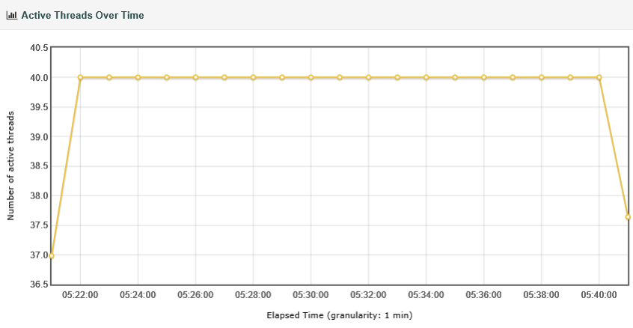

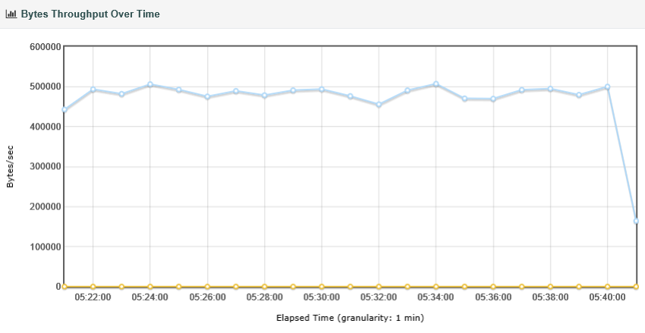 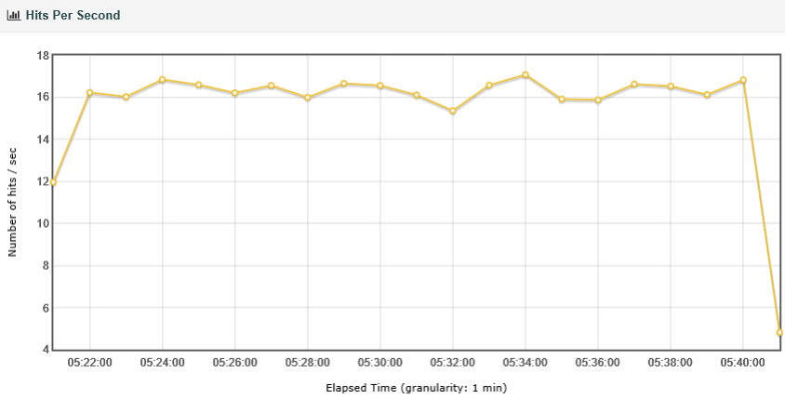

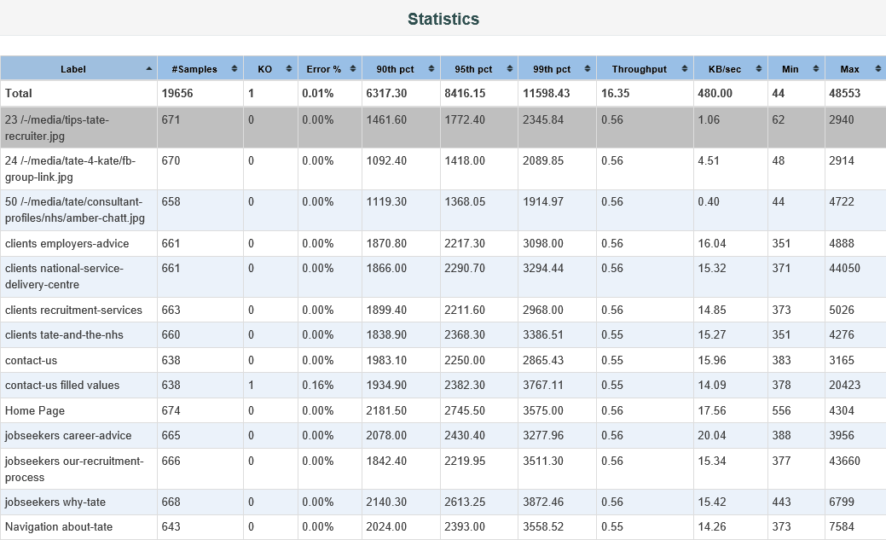 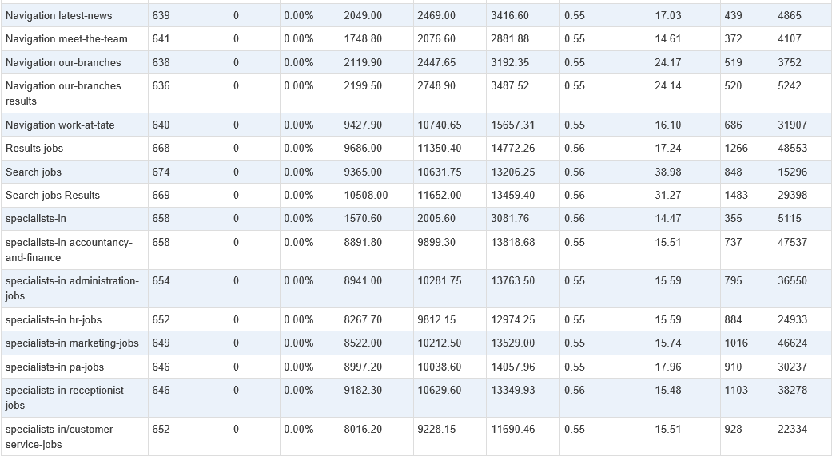

**Test Case 1_ Case 2**: User Attempts to login without authentication

|  |  |
| --- | --- |
| **Start Time:** "26/07/2017 04:38:38.164" \ **End Time:** 26/07/2017 04:58:49.207” |  |
|  |  |

a . Execution Time :- 20 minute (26-july-17)

b. Minimum Response Time :- 58 ms

c. Maximum Response Time :- 40303 ms

d. Average Response Time :- 161 ms

e. Ramp- up Period :- 10 second

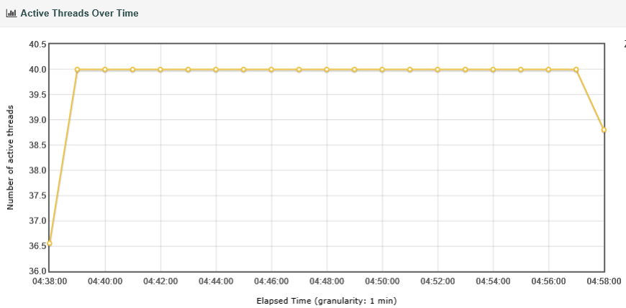

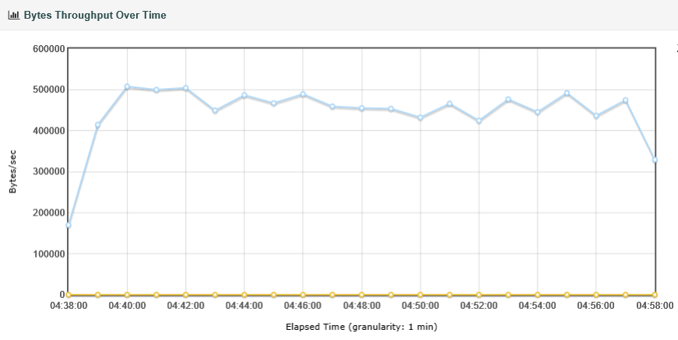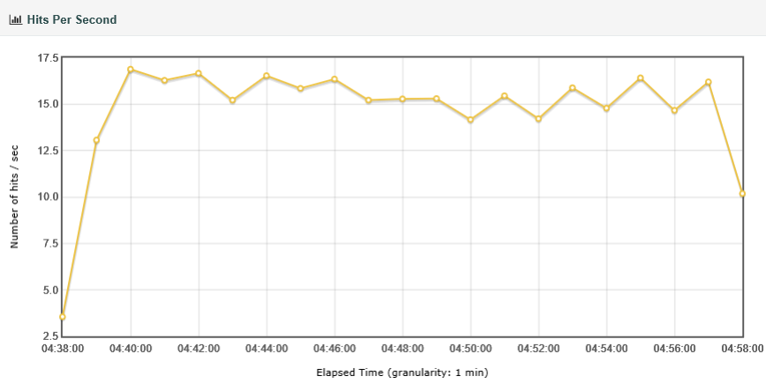

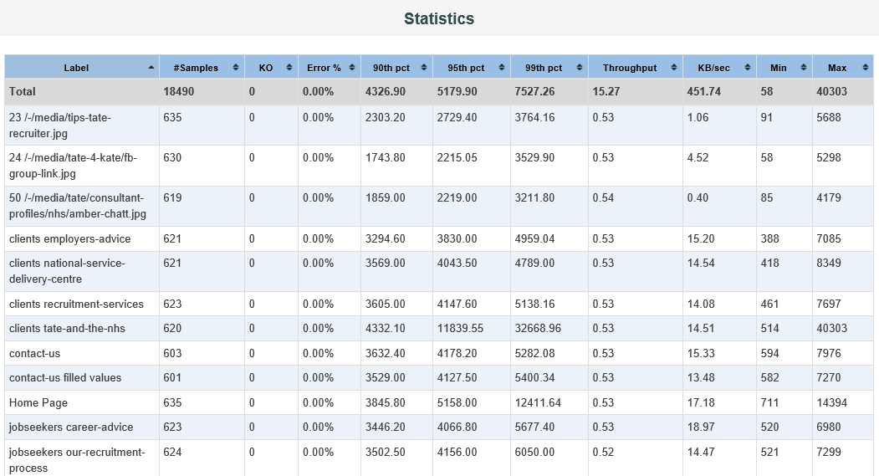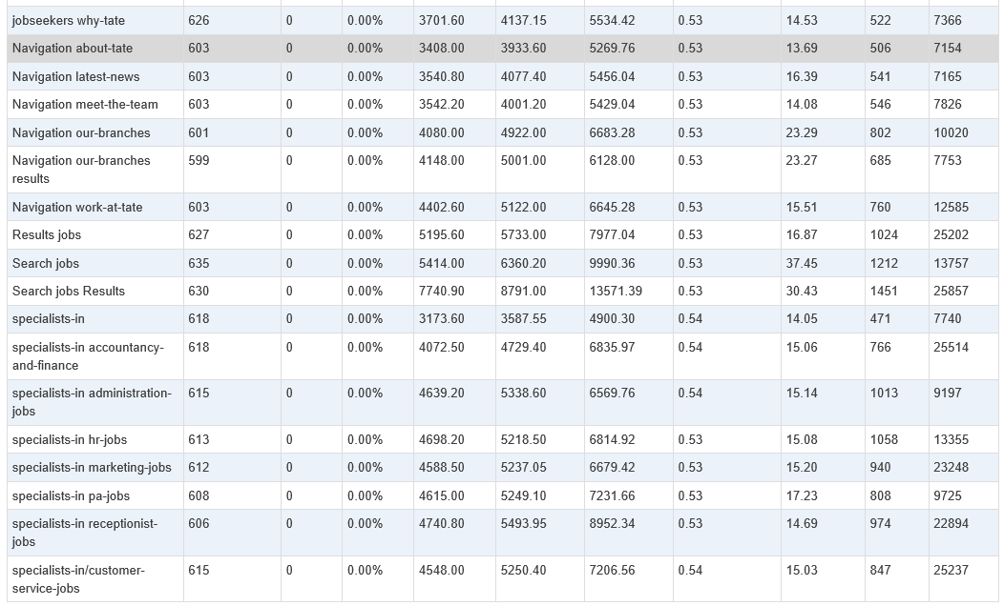

# Final recommendation from Perfomance Testing Team

Performance of the application is within permissible limits and does not show any sign of abnormal response time for User attempts without login. The hit per second, throughput graphs shows similar pattern singnifying with increase of users, throughput is also increasing which is a expected pattern.